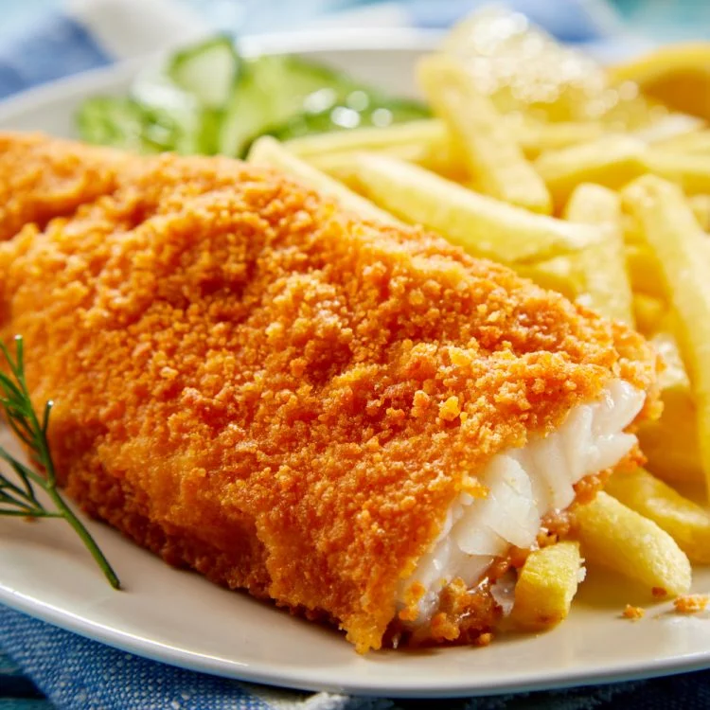 ***Fish Fry Time******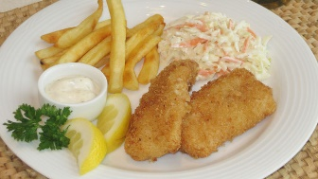***

***The Holy Spirit Knights of Columbus will have their annul Fish Fry on Friday March 22nd 6:30pm to 8pm at the Church Pavilion. Will move to Church Hall if there is bad weather. Proceeds go to help the youth at Holy Spirit Catholic Church to attend Catholic youth conferences this summer.***

***Dinner Menu will be:***

*Fried Cod, French Fries, Cole Slaw, White Beans, Hushpuppies.*

***Drinks:***

*Sweet Tea, Unsweet Tea, Lemonade, Coffee, and Water.*

***Prices:***

*Adults $9, Kids ages 6-12 $5, Kids 5 and under are free, and Family max cost $30.*

***Come on out and get some good food, great fellowship with friends and family.***

***If there are any questions, please contact Kevin Olley. at 423-987-3432***

